Lesson 02 Demo 09

Creating User and Group Accounts

Objective: To create user and group accounts to add the users to the Azure subscription
Tools Required: None

Prerequisites: None

Steps to be followed:
- Add a new user
- Create a new group and add members

Step 1: Add a new user

  - Sign in to the Azure portal as a user administrator and go to the Azure active directory

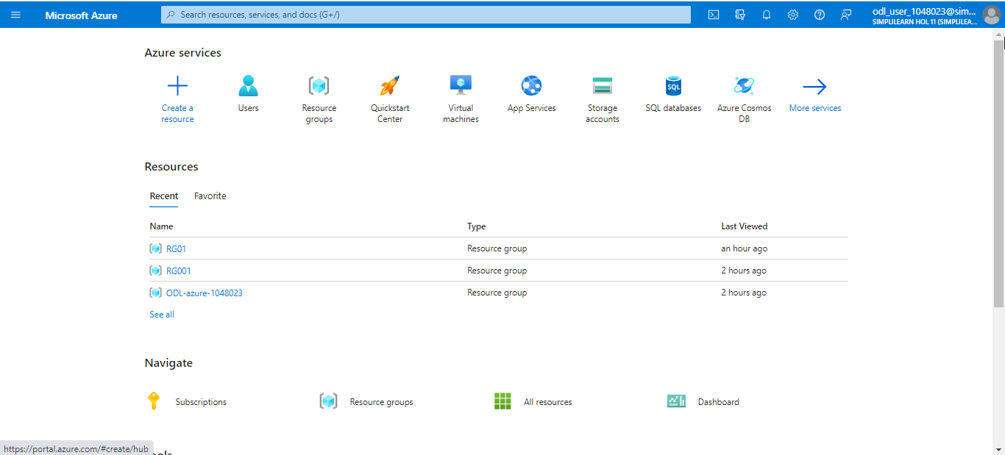

  - Select Users, click on New user, and then click on Create new user

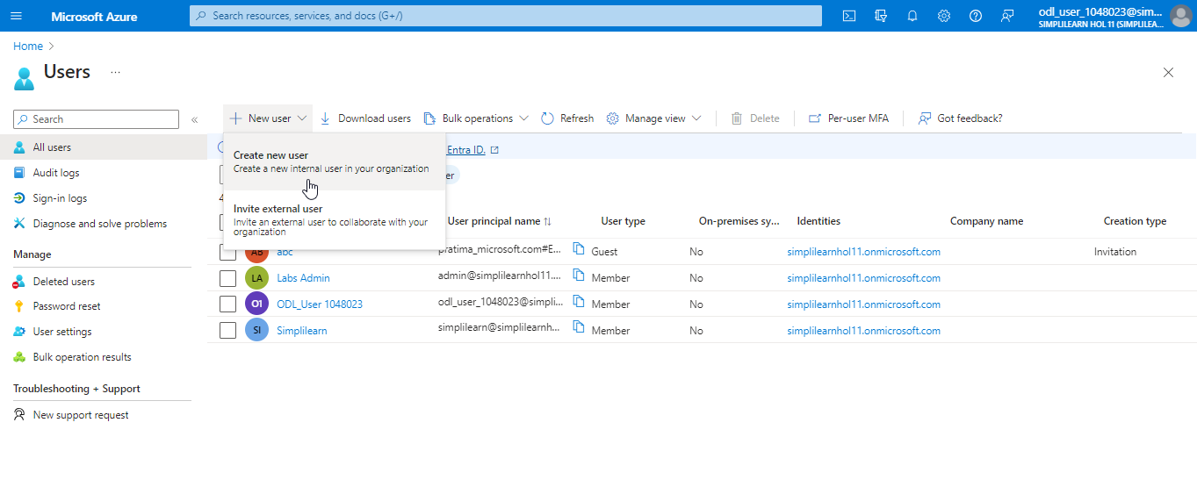

  - Enter the necessary details of the user. Then, click on Next: Properties >

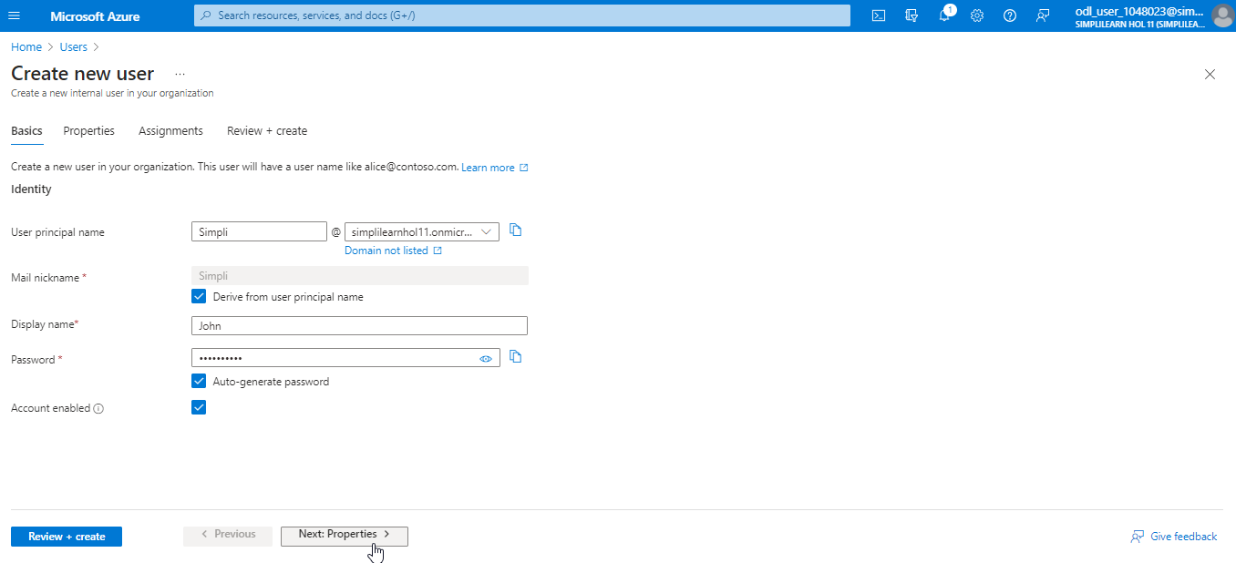

  - Click on Next: Assignment

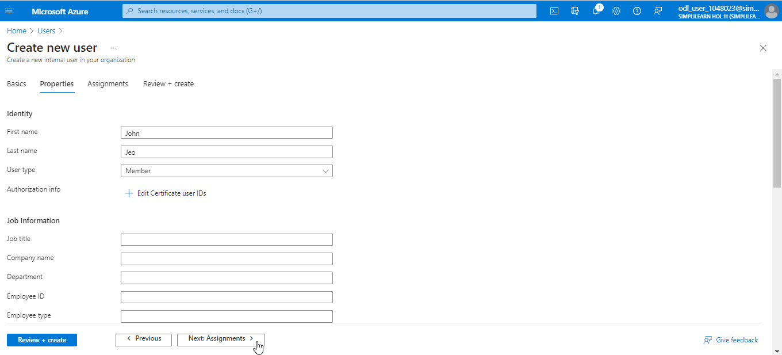

  - Then, select Next: Review + Create

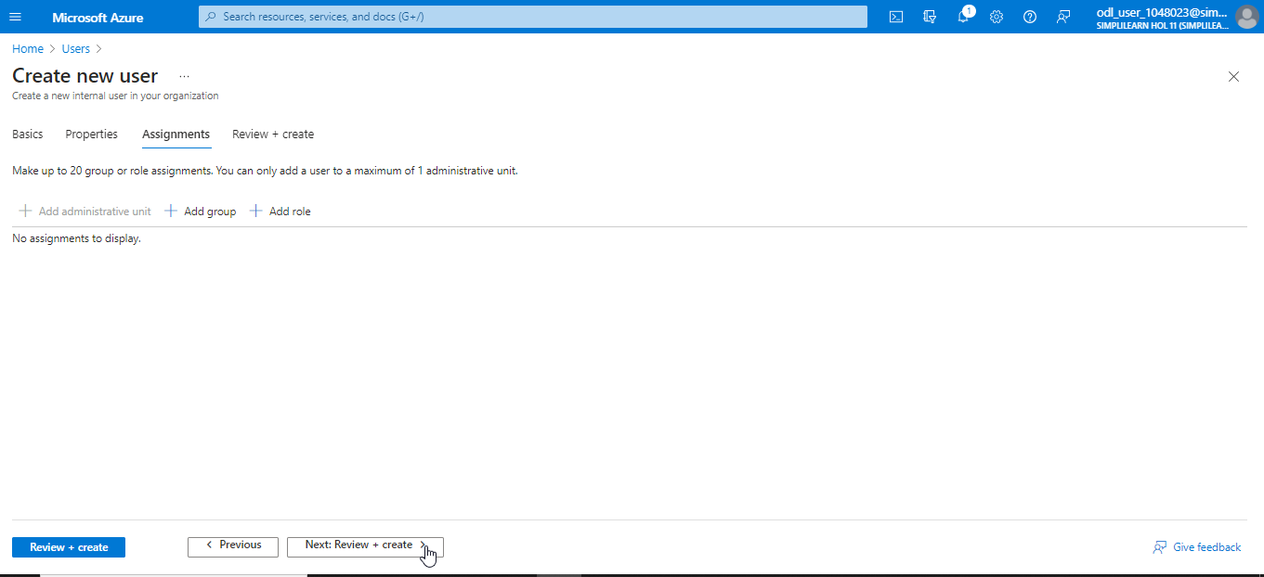

  - Next, click on Create

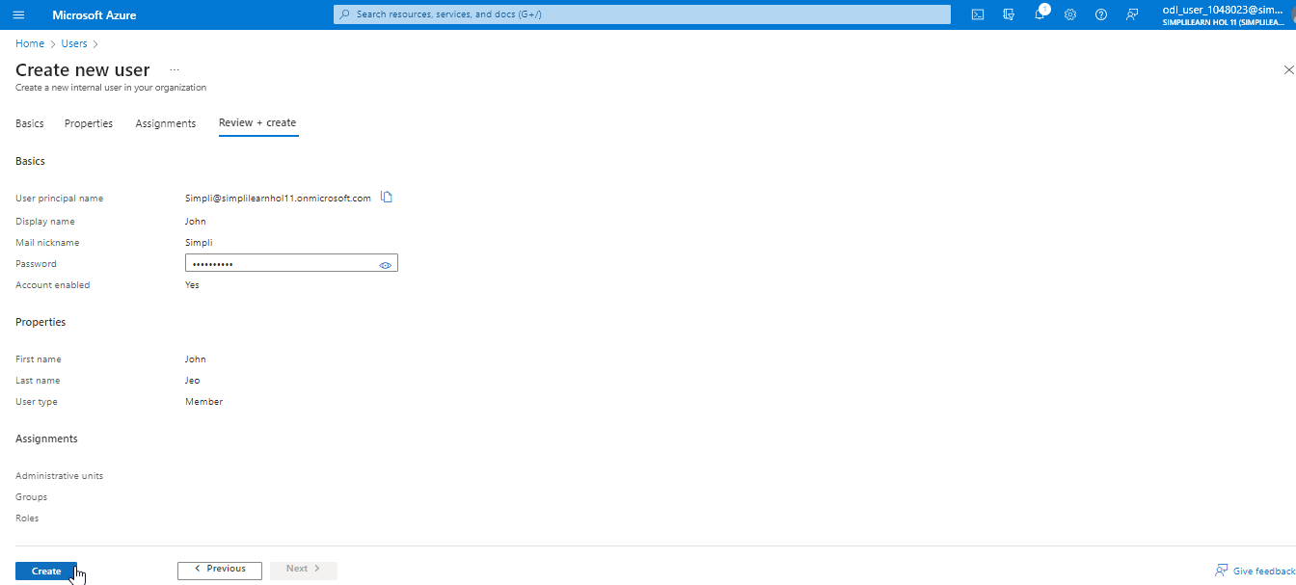

The output appears as follows:

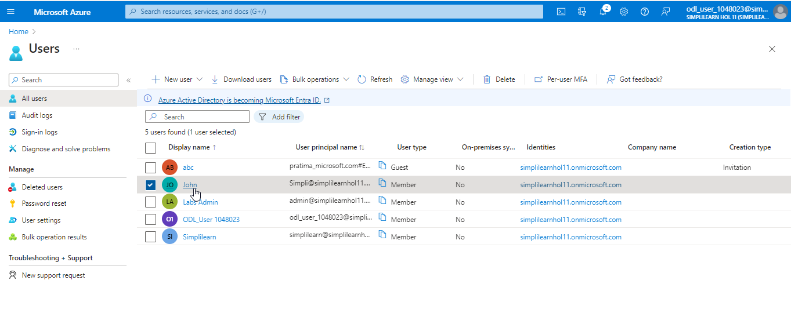

Step 2: Create a new group and add members

  - On the Azure Active Directory page, select Groups

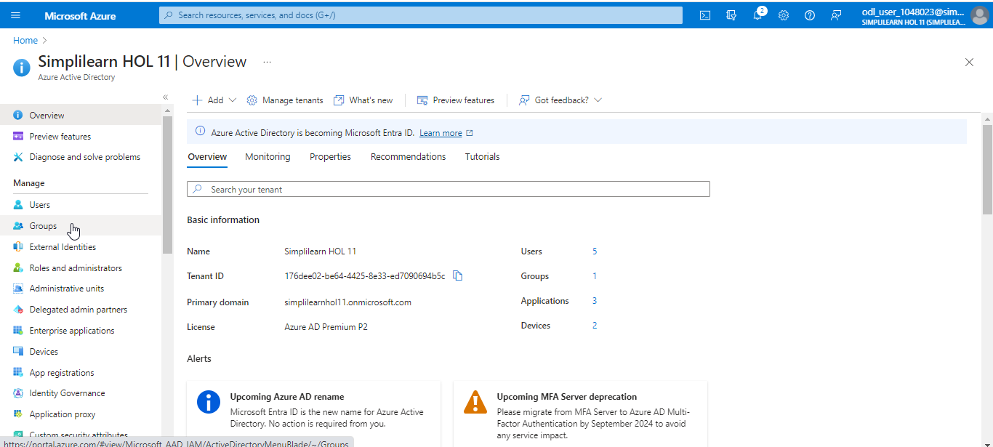

  - Click on New group and provide a group name

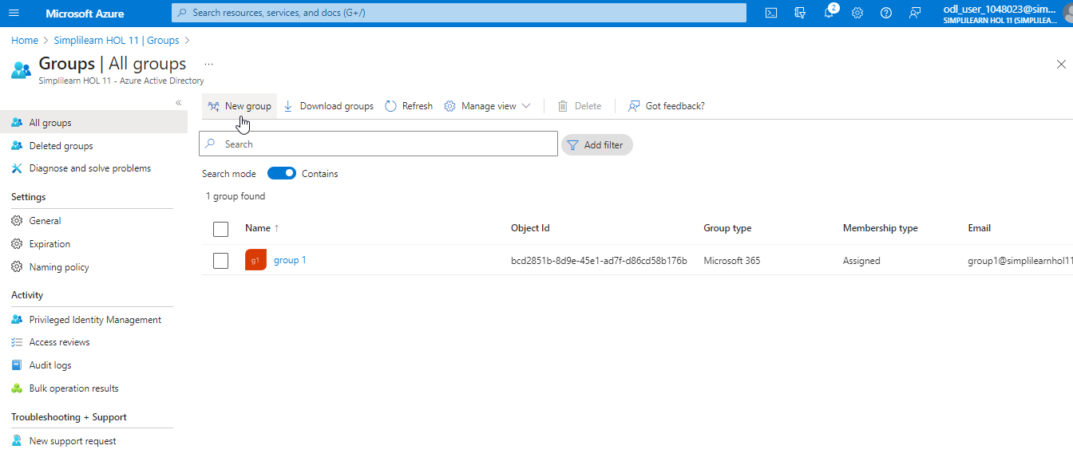

  - Choose the group type and click on create

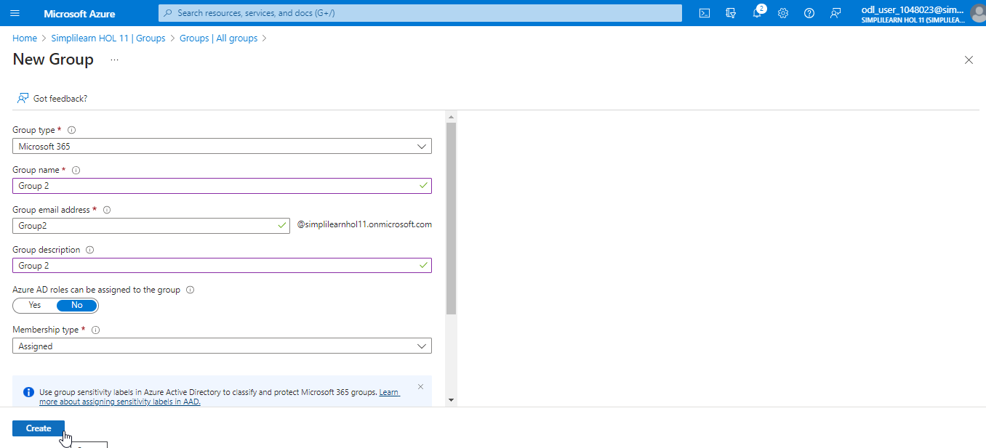

The Group2 is created as shown below:

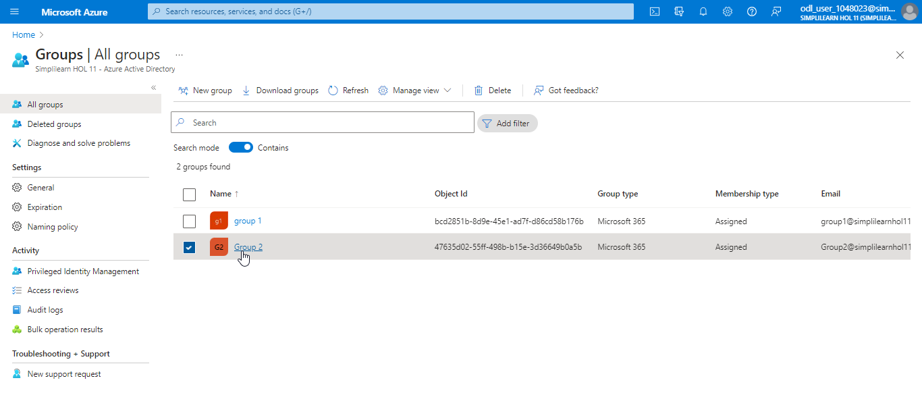

  - Select Members from the Groups page

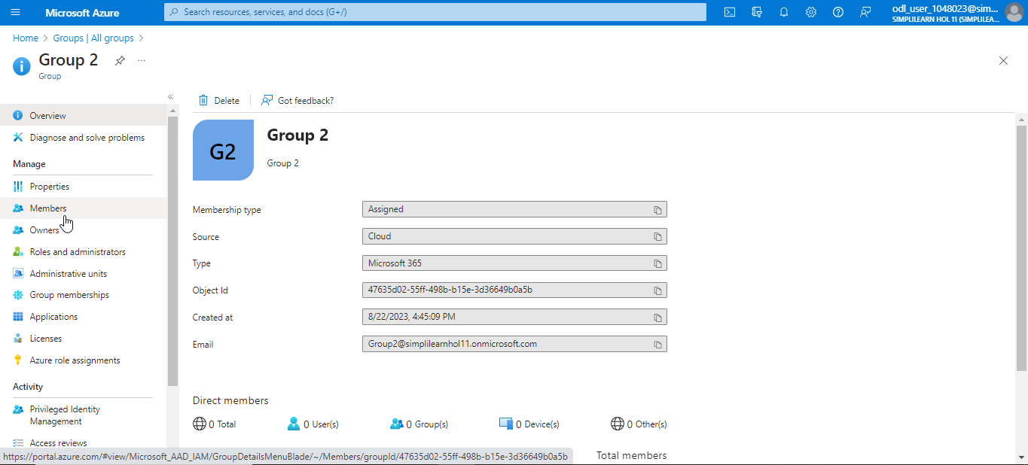

  - Click on Add Members

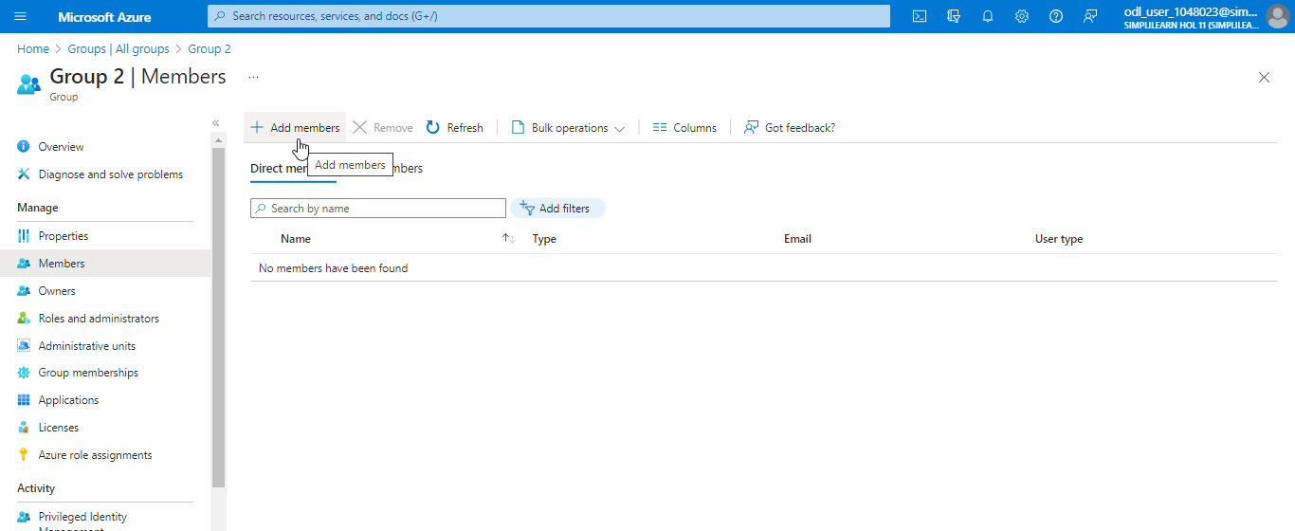

  - Select the user, and then click on the Select button

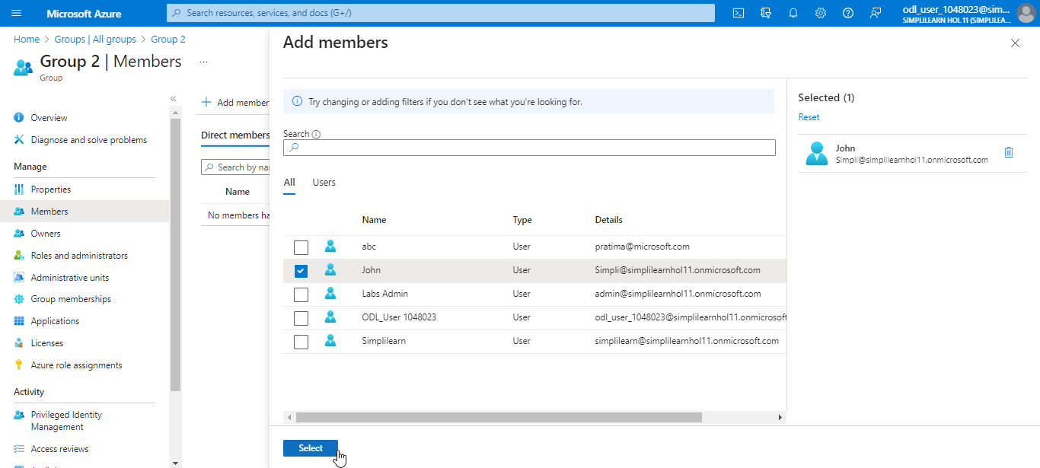

The final output is shown as below:

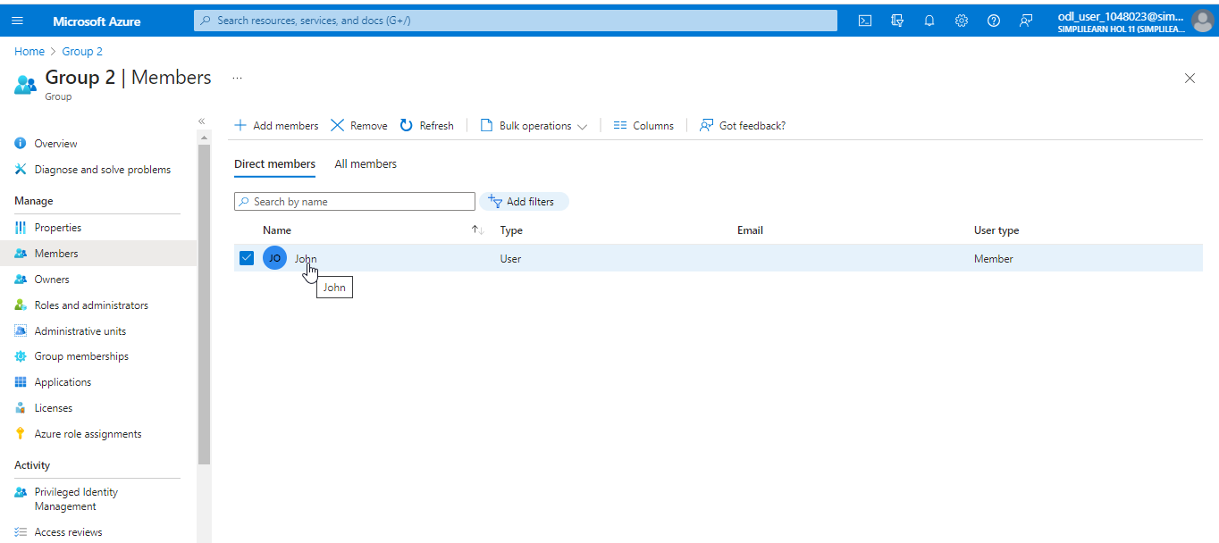

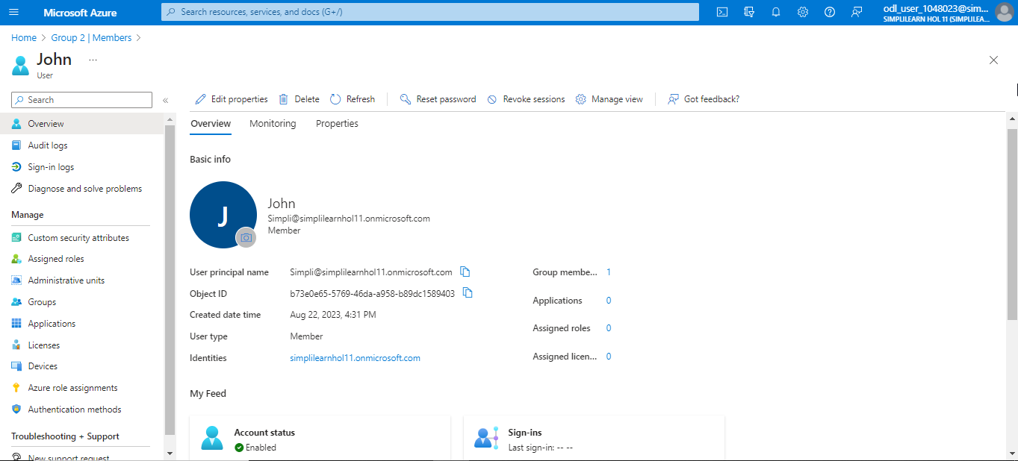

You have now successfully added the users to the Azure subscription, created groups, and assigned users to these groups.

